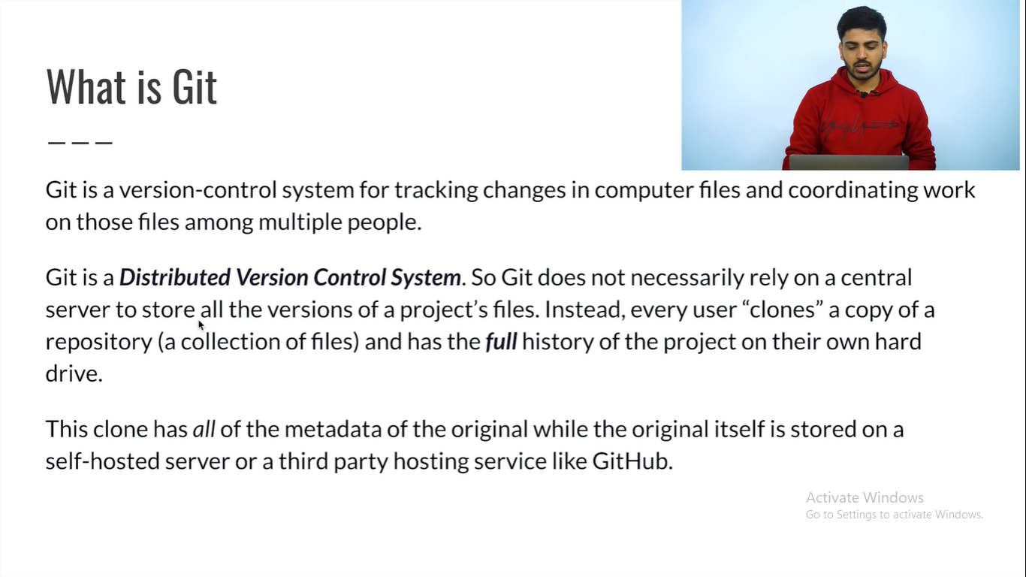

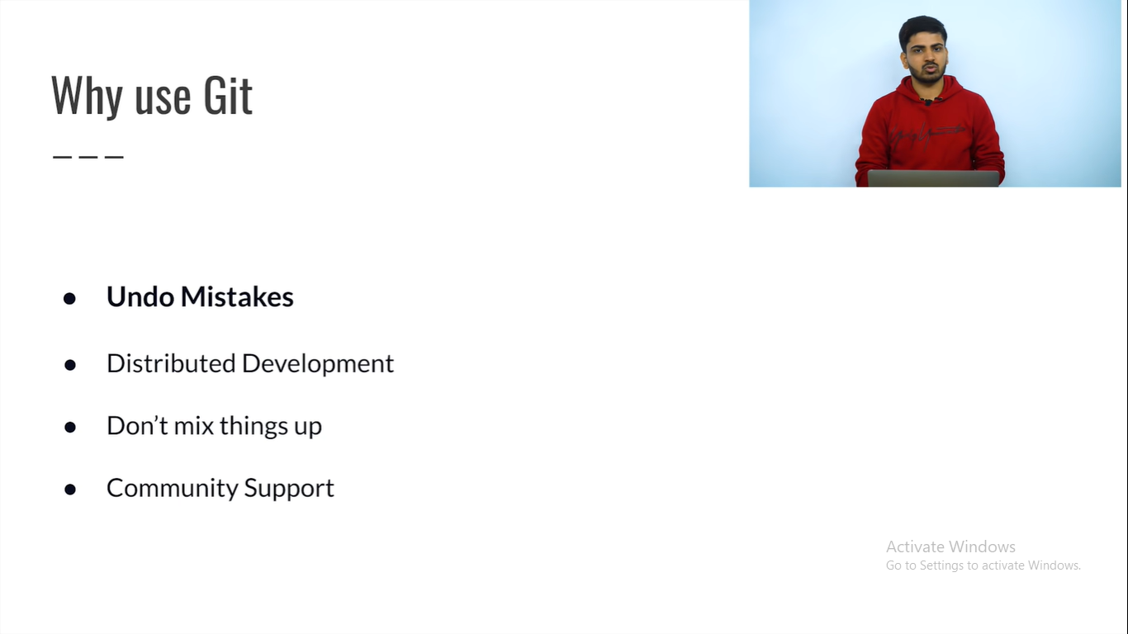

Install git

Open cmd and check whether git is installed or not

>>> git version

Make a folder in your desktop

>>> mkdir LearnGitRepo

Move into your folder

>>> cd LearnGitRepo

To initialize a git repo for new or existing project

>>> git init

To check its status

>>> git status

Add a file in that folder

Adding some files to the staging area

>>> git add file_name

Again chack the status

>>> git status

To commit the changes and make it as a local repo

>>> git commit -m "Message"

To check the details of that file

>>> git log

To remove files from staging area

>>> git rm –cached file_name

To create a new branch with the name

>>> git branch branch_name

To move to that branch

>>> git checkout branch_name

To move to master branch again

>>> git checkout master

To merge any branch into current branch

>>> git merge branch_name

Make a repo there in your GitHub

To add these things in your remote repo

>>> git remote add origin repo_link

To push your local repo in your remote repo

>>> git push –u origin master

To bring your remote repo to your local machine

>>> git pull

For Open Source

Fork it

And then clone it in your local machine

And make a pull request